Wireshark Network Traffic Analysis Report
Introduction:
This report presents an analysis of a network packet capture mesbapcapng.recorded using Wireshark on a virtualized/local network interface eth0. The primary objective is to observe and examine local network protocols, background communication, and how devices interact within a local subnet.

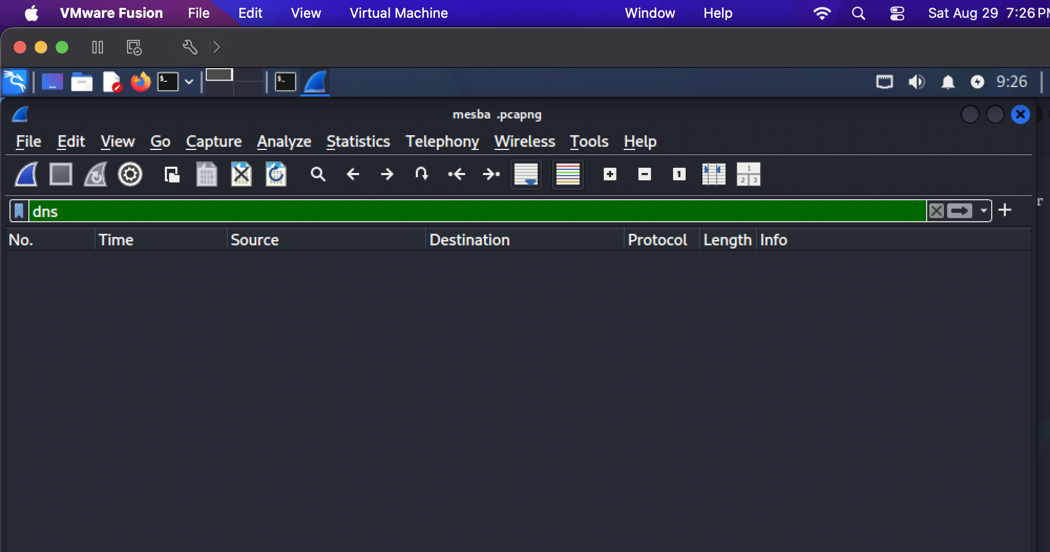

No dns traffic found. Here we found local traffic.
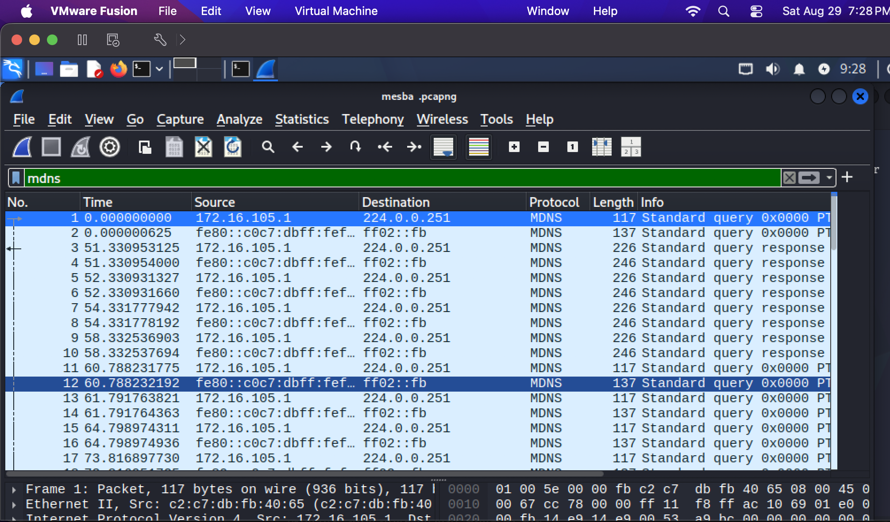
mDNS (Multicast Domain Name System): A large portion of the captured traffic consists of mDNS queries and responses.

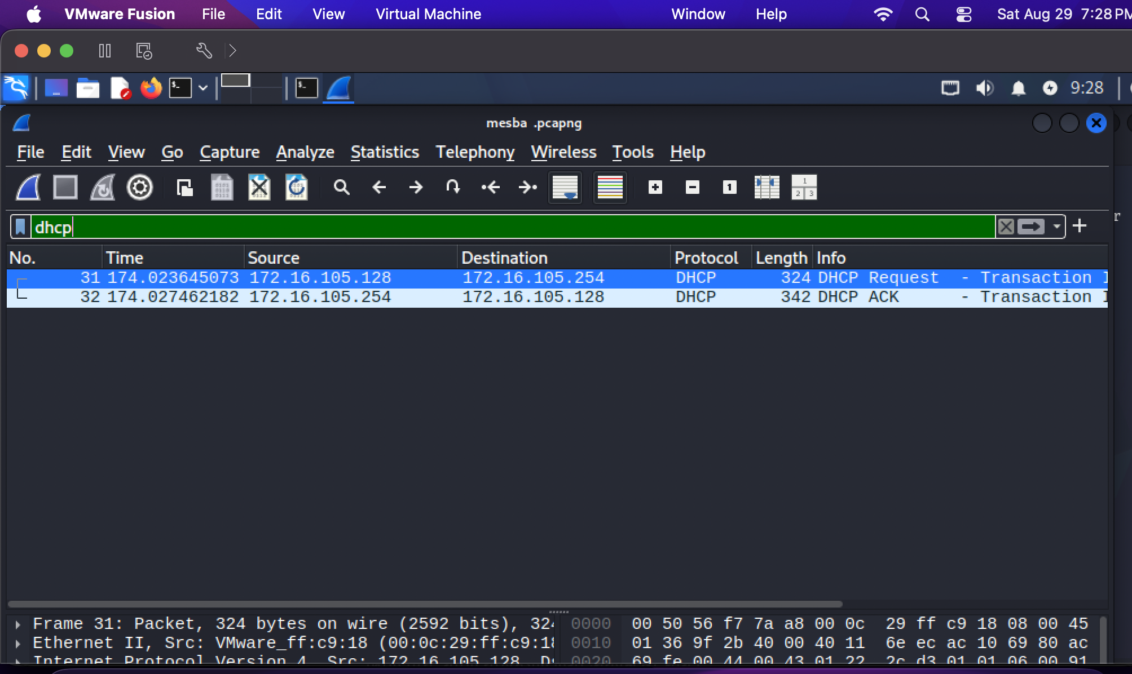
We found very few dhcp protocol
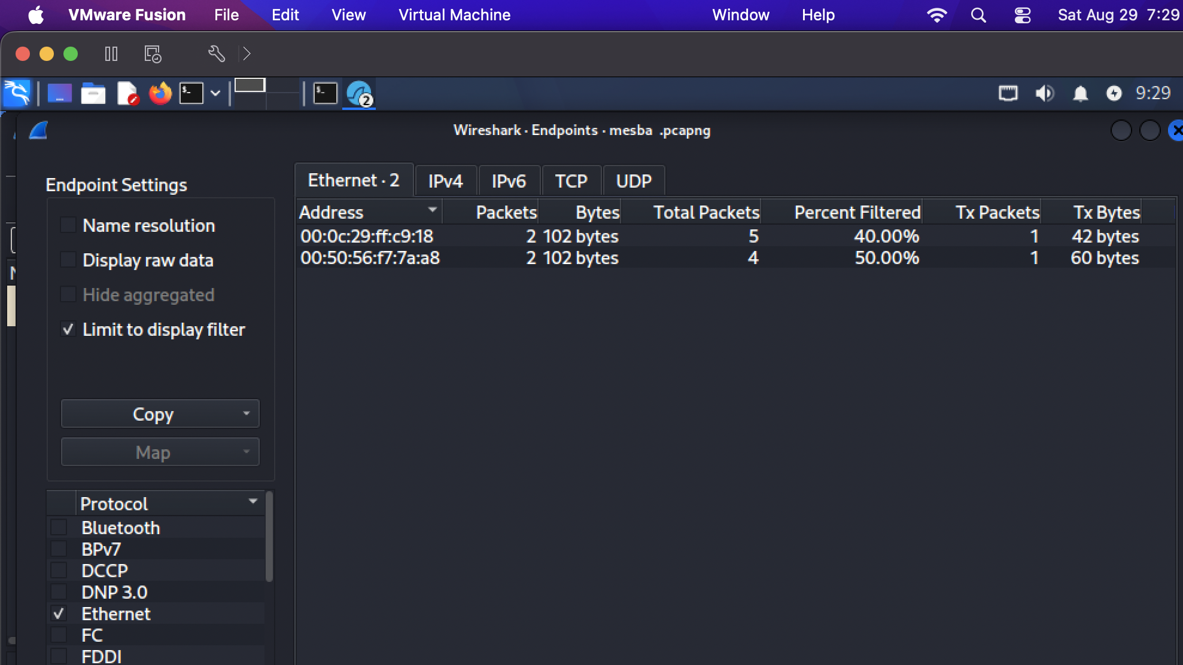
Here is wireshark endpoints
Conclusion
The captured trace successfully demonstrates standard background operations of a local/virtualized network environment, primarily driven by device discovery (mDNS), IP leasing (DHCP), and hardware address mapping (ARP). No abnormal or suspicious external traffic was detected, reflecting normal and healthy network behavior.

